Finding CDS Views
ABAP CDS Files can be searched for based on data source (the table the CDS View references) or by name (by typing the name of the CDS View or a pattern, such as “Z*”).

Finding CDS Views by the Data Source Used
If we wanted to find an ABAP CDS view (DDL Source file) for the table SNWD_SO that we used during the presentation, we can navigate to SE11 and perform a Where-Used on the table.
This search must be performed in the Eclipse Editor’s SAP GUI if you want to forward navigate to the actual CDS view.

- Click the SAP GUI icon while within the Eclipse Editor
- Navigate to transaction SE11
- Type the name of the table you want to view (in this example SNWD_SO)
- Click the Where-Used icon
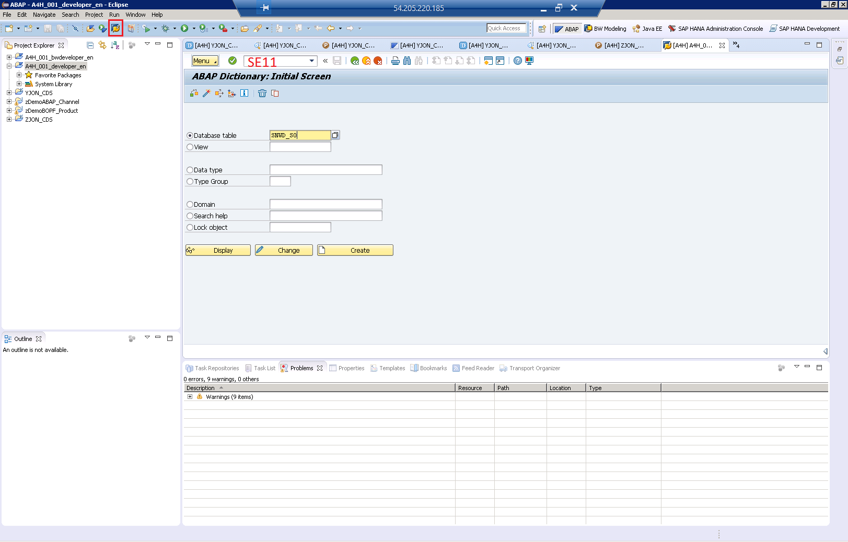

- When prompted for objects types, deselect all options and only select DDL Sources.

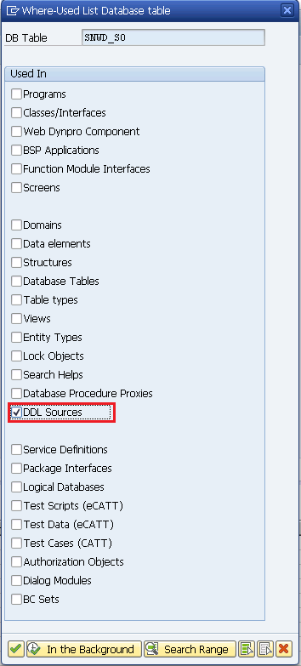
- A list of DDL Sources should appear on the next screen, if any exist.
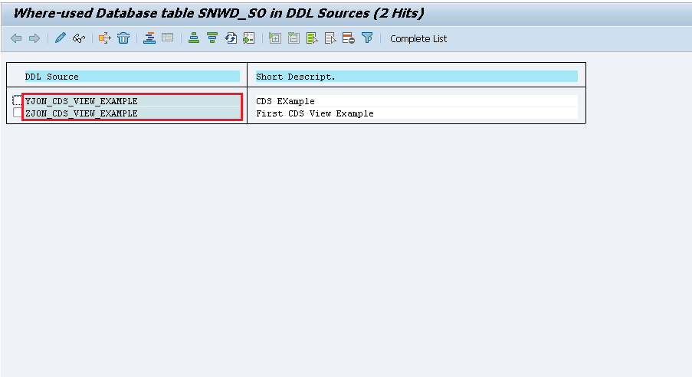

- Double clicking on any DDL Source should allow to forward navigate to the CDS View.

- You can also use the Where-Used button within the Eclipse editor to determine where the CDS View itself is used. To do this, highlight the CDS View name and hit the Where-Used Icon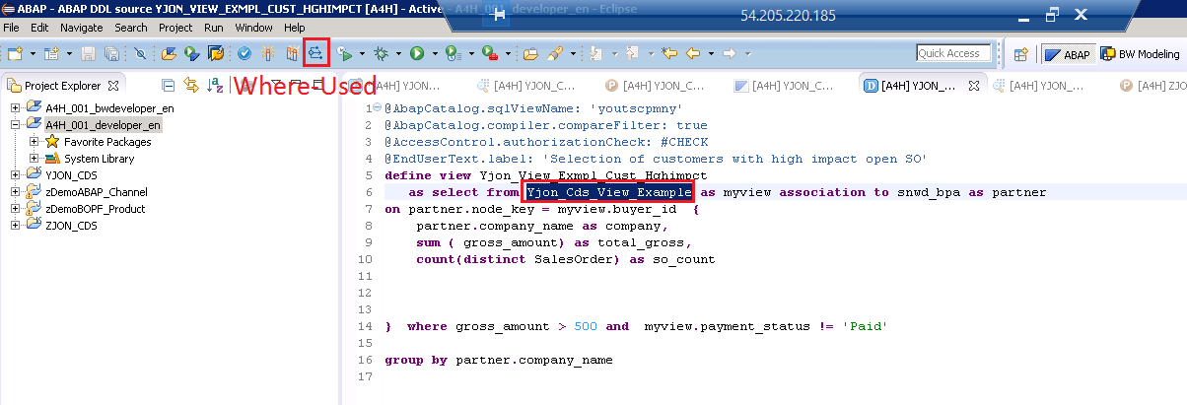

- The search results will appear in the content pane at the bottom of the screen. This will identify any locations where this object is used, and summarize how it is used (in a SELECT statement, etc).

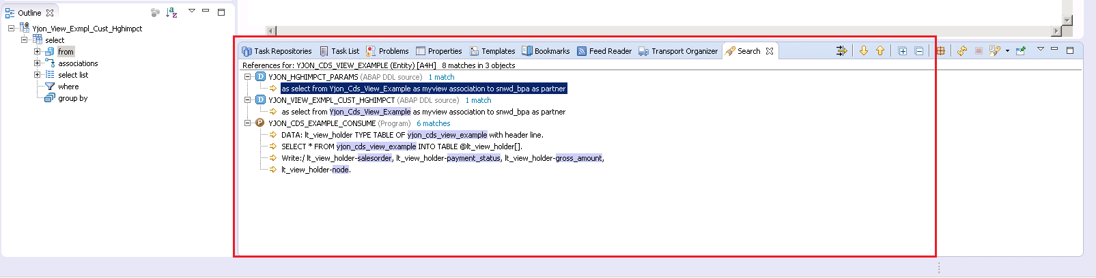

Finding CDS Views by Name

- While in the ABAP perspective, press the keys CTRL+SHIFT+A simultaneously to bring up the development object search box.
- Enter the pattern you want to search for in the system (for instance, so search all CDS views beginning with a “Z”, enter the pattern “Z*”
- After the pattern, enter the text “type:ddls” to specify you want the search restricted by DDLS source files (CDS Views and Table functions).
- Double-click on any matching items for forward navigate to the object.
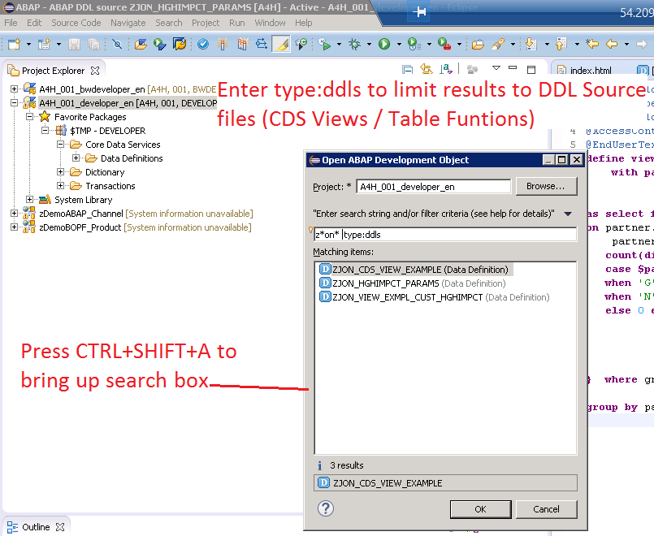

In addition, you perform this search with no pattern to pull all CDS Views and Table Functions within the system (only enter “type:ddls” in the search field):
